NAME: SRUTI VERMA
REGISTRATION NUMBER:18BCE1005
COST AND EFFORT ESTIMATION

FUNCTION POINT MODEL: It is based on the visible features of the system that are weighed accordingly to produce an overall score. The intent is to construct a measure of product size that can be available easily in the development process. It is based on the notion of function points regarding as a measure of functionality of the system. The starting point of the construction of the model is to determine the number of items occurring in the system.
The items are as follows:
External inputs are the inputs from the user that provide distinct application oriented data. Examples of such inputs are filenames and menu selections.
External outputs are directed to the user, they come in the form of various reports and messages.
User inquiries are interactive inputs requiring the response.
External files deal with all machine readable interfaces on other systems.
Internal files are the master files in the system.
These items are related differently according to their complexity that is given below in the following table.
Item | Simple | Average | Complex
External Inputs | 3 | 4 | 6
External Outputs | 4 | 5 | 7
User Inquiries | 3 | 4 | 6
External files | 7 | 10 | 15
Internal files | 5 | 7 | 10

Here, first the Unadjusted Function Count (UFC) is determined using the formula
UFC = ∑itemi wi
In the second phase, refining the Function Point Count by including Technical Complexity Factor (TCF) and multiplying the value with UFC by using the formula determine Adjusted Function Point Count (FP):
FP = UFC * TCF

Where TCF is calculated using the formula:
TCF = 0.65 + 0.1∑fi
Where fi specifies the detailed factors contributing to the overall notion of complexity.

The various factors are as follows-
•€Reliable Backup and Recovery
•€Distributed Functions
•€Heavily used Configuration
•€Operational Use
•€Complex Interface
•€Reusability
•€Multiple sites
•€Data Communications
•€Performance
•€Online Data Entry
•€Online Update
•€Complex Processing
•€Installation Ease
•€Facilitate Change
Here each factor is rated on 0 to 5 scales with 0 being irrelevant and 5 standing for essential. If al the factors are irrelevant then the constant 0.65 is used otherwise the constant 1.35 is used.

Considering the Data Automation System the items are as follows-
External inputs – 37 (complaint no, complaint Id, complaint Name, complaint Type, Location, Area, . . .)
External outputs – 3 (Confirmation of complaint registration, Confirmation to Data Entry Clerk, validate proof)
User inquiries – 5 (status of case, status of criminal, .....)
External Files – (Client info files)
Internal Files – 7 (victim or User’s info files)

Considering the Data Automation System, we assume the complexity of all items to be average.

So, UFC = (4*37) + (5*3) + (4*5) + (10*1) + (7*7)
= 148 + 15 + 20 + 10 + 49
=242
TCF = 0.65 + 0.1(5 + 0 + 0 + 5 + 1 + 1 + 0 + 3 + 0 + 0 + 1 + 2)
= 2.45

Therefore FP = UFC*TCF
225.059998
DI=28

Coding:
#include<stdio.h>
#include<conio.h>
int fround(float x)
{
int a;
x=x+0.5;
a=x;
return(a);
}

int main()
{
int weights[5][3]={3,4,6,4,5,6,3,4,6,7,10,15,5,7,10};
int UFP=0,F=0,rating,i,j;
char func_units[][30]={"External Inputs","External Outputs","External Enquiries","Internal Logical Files","External Interface Files"};
char complexity[3][10]={"low","average","high"};
int input[5][3];
float FP,CAF;

for(i=0;i<5;i++)
{
for(j=0;j<3;j++)
{
printf("\nEnter number of %s %s : ",complexity[j],func_units[i]);
scanf("%d",&input[i][j]);
}
}

//calculating UFP

for(i=0;i<5;i++)
{
for(j=0;j<3;j++)
{
UFP=UFP+(input[i][j]*weights[i][j]);
}
}

printf("\nUnadjusted Function Point(UFP) = %d",UFP);

printf("\nEnter Rating of 14 factors on the scale of 0-5 :\n");
printf("\n 0 - No Influence");
printf("\n 1 - Incidental");
printf("\n 2 - Moderate");
printf("\n 3 - Average");
printf("\n 4 - Significant");
printf("\n 5 - Essential");

printf("\n");

for(i=0;i<14;i++)
{
scanf("%d",&rating);
F=F+rating;
}

CAF=0.65+0.01*F;

FP=UFP*CAF;

printf("\nAdjusted Function Point = %f",FP);
printf("\nOR FP = %d",fround(FP));

getch();
}
Screen shots:
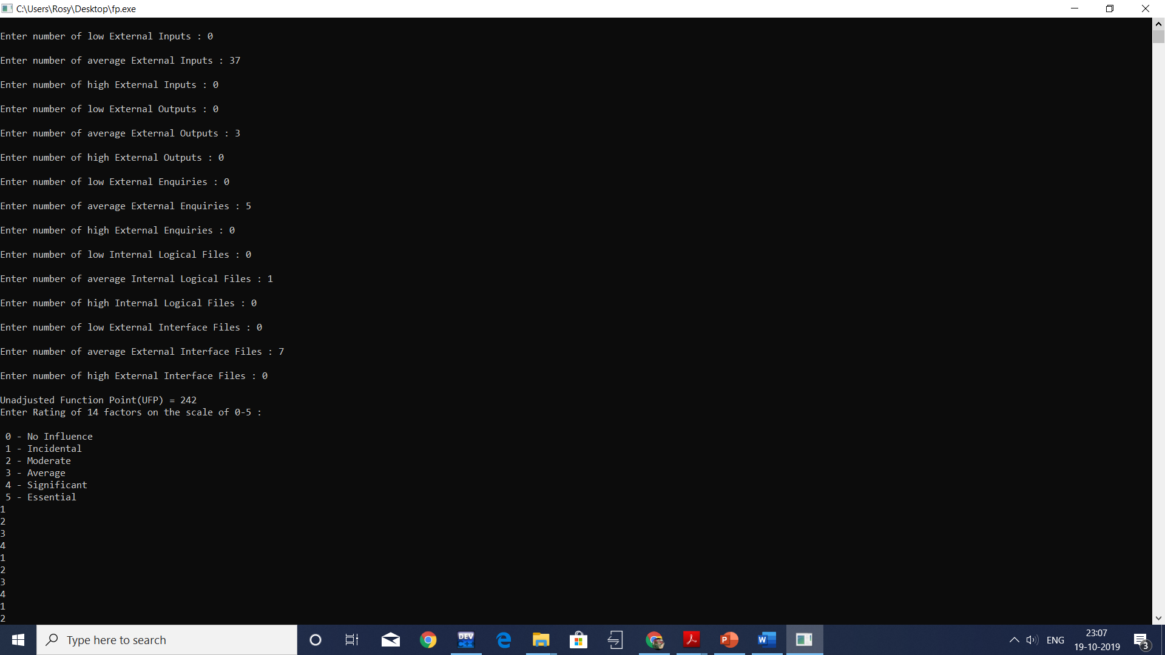

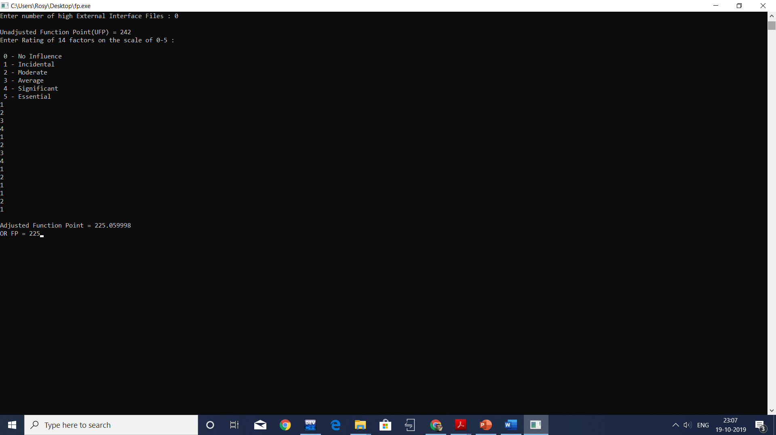

Enter number of low External Inputs : 0

Enter number of average External Inputs : 37

Enter number of high External Inputs : 0

Enter number of low External Outputs : 0

Enter number of average External Outputs : 3

Enter number of high External Outputs : 0

Enter number of low External Enquiries : 0

Enter number of average External Enquiries : 5

Enter number of high External Enquiries : 0

Enter number of low Internal Logical Files : 0

Enter number of average Internal Logical Files : 1

Enter number of high Internal Logical Files : 0

Enter number of low External Interface Files : 0

Enter number of average External Interface Files : 7

Enter number of high External Interface Files : 0

Unadjusted Function Point(UFP) = 242
Enter Rating of 14 factors on the scale of 0-5 :

0 - No Influence
1 - Incidental
2 - Moderate
3 - Average
4 - Significant
5 - Essential
1
2
3
4
1
2
3
4
1
2
1
1
2
1

Adjusted Function Point = 225.059998
OR FP = 225
DI=28

